AutoSAP CIF job Monitoring
Solution Manager signatures signify that approvers have read, understood, and agrees with the content of this document.
Name | Job Title and Role
Akoju Sharanya | The author is signing to confirm that this document has been prepared in accordance with an approved document management process, that content is consistent with the deliverable definition found in Specify System, that relevant input from any contributory authors has been included and that an appropriate review / editing process has been conducted.
Nikhil Chalikwar | The Developer (selected by the Project Manager as responsible for the design of the system) is signing to confirm that the Design Specification is fit for purpose, that it will deliver a computer system that satisfies the System Requirements and that it will be used for the development or configuration of the computer system

Table of Contents
1 Introduction 3
2 Definition/Acronyms 3
3 General Statement of Design 3
3.1 Assumptions 3
4 References 3
5 Platform Architecture and Environment 3
6 Software Architecture 4
6.1 Generic Solution Details 4
7 System Operation Specification 6
8 Data 6
9 Security 6
10 Revision History 7
11 Appendices 7
12 Appendix – Program Logic…………………………………………………………………… .8

Introduction
The system will log in into SBP system to check the job failures using sm37 T-Code. This document describes the automation of APO CIF job Monitoring.

Definition/Acronyms
Item | Definition
API | Application Programme Interface
SAP | Systems Applications and Products

General Statement of Design
Design methodology/principles | This task is developed to overcome the manual effort and time spent on routine activity. The scripts are developed for end-end execution of Automation process of SBP CIF job Monitoring.  The automation script will log in into SBP system of SAP to check the status of all jobs using sm37T-code and will send an alert email with the evidence.
Tools + version | Python 3.10, Pandas, SAP GUI 760, wincom32 API, SMTP Mail.
Programming standards | GSK Programming Standards.

Assumptions
Assuming the t-codes sm37 T-code is working fine.

References
None

Platform Architecture and Environment
python v3.10

Software Architecture
Element ID | Developed Software Unit name | ID | Programming Language(s) | Description of Purpose
APO_CIF-Jobmonitoring/0001 | Program | autosapcif.py | Python | This is the main file which imports functions from other Python files to monitor SAP jobs, continuously checking statuses and sending email alerts (RED for issues, GREEN for success) until all jobs are completed.
APO_CIF-Jobmonitoring/0002 | Program | cif.py | Python | This file is responsible for checking the status of jobs, capturing their statuses, and generating reports based on the job status.
APO_CIF-Jobmonitoring/0003 | Program | cc.py | Python | This file reads the credentials
APO_CIF-Jobmonitoring/0004 | Program | logon.py | Python | This file will login into SAP GUI
APO_CIF-Jobmonitoring/0005 | Program | sender.py | Python | Sends mail to the required recipients with summary report in mail body and all the evidence in attachments.

Generic Solution Details
Authorisations
No Authorisations checks implemented as Authorisations are derived from user.
Message Class and Messages:
NA

Manual Process:
SYSTEM: SBP
Step1: login into SBP system, enter the transaction /nsm37.
Enter the Job Name as: z_*APO_D_CIF_DELTA and
Enter the User Name as: *
Select all the Job Status options, and for the "From" and "To" dates, enter the current date you are executing the task and click on execute.

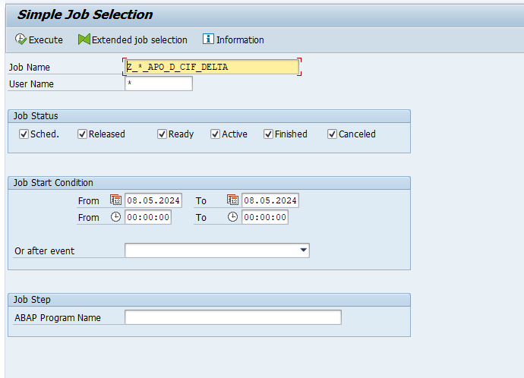

Step2: Monitor the Status of jobname like Finished, scheduled, cancelled.
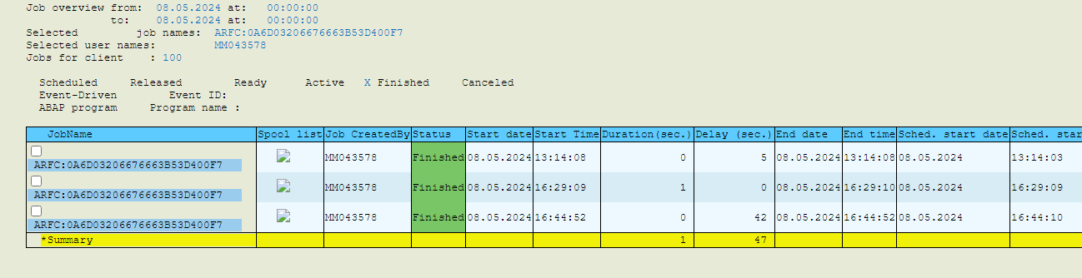

Step3: sends an email alert based on the job's status with the evidence attached.

Input Format
NA
Output Format
NA
Output Medium
Print
Screen Summary
NA
Business Logic:
For detailed specification of the development please refer to Appendix – Program Logic
Run Mode
Foreground

System Operation Specification
NA

Data
NA

Security
NA

Revision History
Version | Source |  | Reason For Revision
Version | Deployment | BAU | Reason For Revision
1.0 | July-2024. | NA | This is the first issue of the document and initial version created for AutoSAP_001.

Appendices

Appendix – Selection Screen Definitions
NA
Appendix – Testing Objective
- For every 20min the CIF job monitoring is done by logging into SBP system.
- This process involves checking the sm37 T-code for Job status like finished or cancelled or scheduled.
- At the end of monitoring a report is prepared and an email notification is sent to APO team summarizing the monitoring results.
Appendix – Screen Layout Definition
NA

Appendix – Program Logic
Element ID | Logic Description
Autosap_APO – CIF Job Monitoring | Step 1:  - Log in to the SBP system.  - Enter transaction code `/nsm37`.  - Enter the Job Name as: z_*APO_D_CIF_DELTA and  - Enter the User Name as: *  - Select all the Job Status options, and for the "From" and "To" dates, enter the current date you are executing the task and click on execute.  Step 2:  - Check the status of the Jobnames finished, scheduled, or cancelled  Step 3:  - sends an alert email with evidence to team depending on the status of job like  the subject name is [RED] AutoSAP CIF job monitoring if Job cancels.  the subject name is [GREEN] AutoSAP CIF job monitoring if Job finishes.  the subject name is [FYI] CIF job monitoring is started if Jobs are in scheduled
Appendix – Output Layout Details
NA
Appendix – Sample Output Formats
1. The subject name is [GREEN] AutoSAP CIF job monitoring if Job finishes.
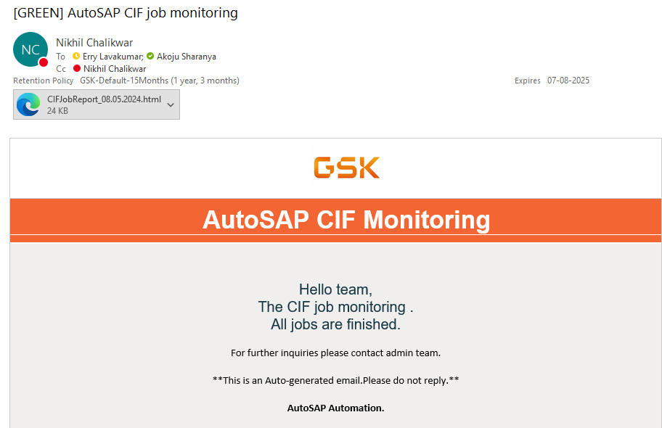
2. The subject name is [RED] AutoSAP CIF job monitoring if Job cancels.
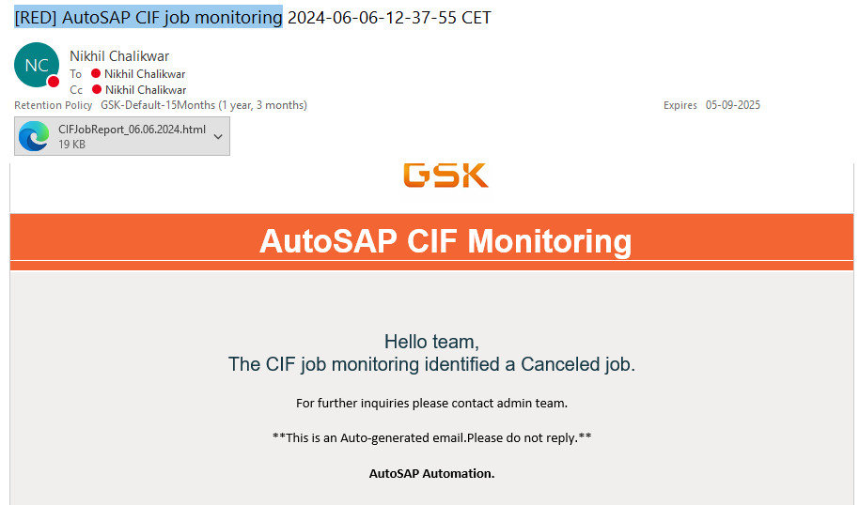

3. The subject name is [FYI] CIF job monitoring is started if Jobs are in scheduled.
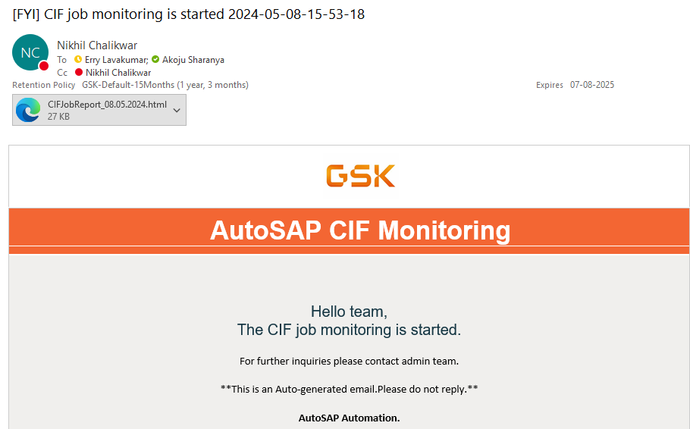

Appendix – Function Module Detail
NA
Appendix – Further Solution-specific sections
NA
Appendix – IDOC Detail
NA
Appendix – Data Dictionary Objects
NA
Appendix – Portal / Java Developments
NA
Appendix – Data
NA

